Develop an Android application using controls like Button, TextView, EditText for designing a Calculator having basic functionality like Addition, Subtraction, Multiplication, and Division.
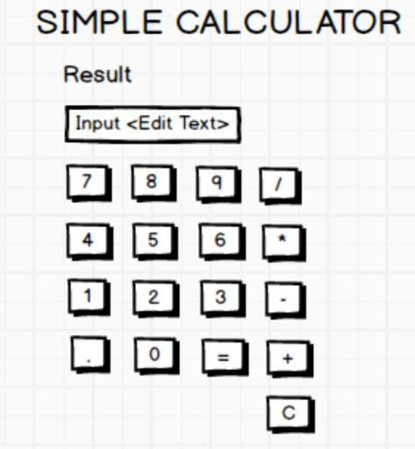
package com.example.calc;
import android.os.Bundle;
import android.view.View;
import android.widget.Button;
import android.widget.EditText;
import androidx.activity.EdgeToEdge;
import androidx.appcompat.app.AppCompatActivity;
public class MainActivity extends AppCompatActivity {
Button b1,b2,bplus,beql;
EditText ET_Result;
Float v1, v2;
Boolean add;
@Override
protected void onCreate(Bundle savedInstanceState) {
super.onCreate(savedInstanceState);
EdgeToEdge.enable(this);
setContentView(R.layout.activity_main);
b1 = findViewById(R.id.btn_one);
b2 = findViewById(R.id.btn_two);
bplus = findViewById(R.id.btn_plus);
beql = findViewById(R.id.btn_eql);
ET_Result = findViewById(R.id.ET_Result);
b1.setOnClickListener(new View.OnClickListener() {
@Override
public void onClick(View view) {
ET_Result.setText(ET_Result.getText().toString()+"1");
}
});
b2.setOnClickListener(new View.OnClickListener() {
@Override
public void onClick(View view) {
ET_Result.setText(ET_Result.getText().toString()+"2");
}
});
bplus.setOnClickListener(new View.OnClickListener() {
@Override
public void onClick(View view) {
v1 = Float.parseFloat(ET_Result.getText().toString());
add = true;
ET_Result.setText(null);
}
});
beql.setOnClickListener(new View.OnClickListener() {
@Override
public void onClick(View view) {
v2 = Float.parseFloat(String.valueOf(ET_Result.getText().toString()));
if (add) {
ET_Result.setText(v1+v2+"");
add = false;
}
}
});
}
}

